PART 5 – THE TREASURY PLUMBING THEY NEVER EXPLAIN
Where does authority terminate?

The simplest story states tell about money is usually the least accurate.
moneyweasel
Apr 03, 2026
In the public telling, tax is paid by the citizen, received by the government, and then spent on services according to political choice. It is neat, morally intelligible, and politically useful. It implies a straight line from person to state, and an equally straightforward chain of accountability back the other way.
The official record describes something else.
What the recent FOIA stack has shown, taken together, is that the financial architecture of the British state is not organised around a single pot into which money simply falls. It is organised through a layered system of collection, surrender, fund administration, debt management, registries and unclaimed liabilities. Departments collect. Funds receive. Treasury administers. Debt machinery manages. Registries record only certain forms of title. The public is offered the façade of simplicity; the official documents describe a machine.
That distinction matters, because if the legal and accounting reality is more complex than the political story, then public scrutiny begins at a disadvantage. Citizens are encouraged to think in straight lines while the state operates through layers.
The first point to grasp is that the collector is not always the principal. HMRC’s own position makes that clear. In its replies, HMRC states that tax liabilities are treated as non-transferable personal obligations and are not securitised, and that the relationship between HMRC and taxpayers is statutory rather than fiduciary. Once collected, those revenues form part of the general revenues of the state in the Consolidated Fund, managed by HM Treasury under Parliamentary authority.
That may sound technical, but it is the beginning of the whole issue. The public is encouraged to imagine a simple payment into “government”. The formal position is more exact than that. Tax is collected under statute. It is not a trust arrangement. It is not a personal fiduciary relationship. And the destination of those revenues is not the departmental property of HMRC in the ordinary sense, but part of the wider Exchequer structure.

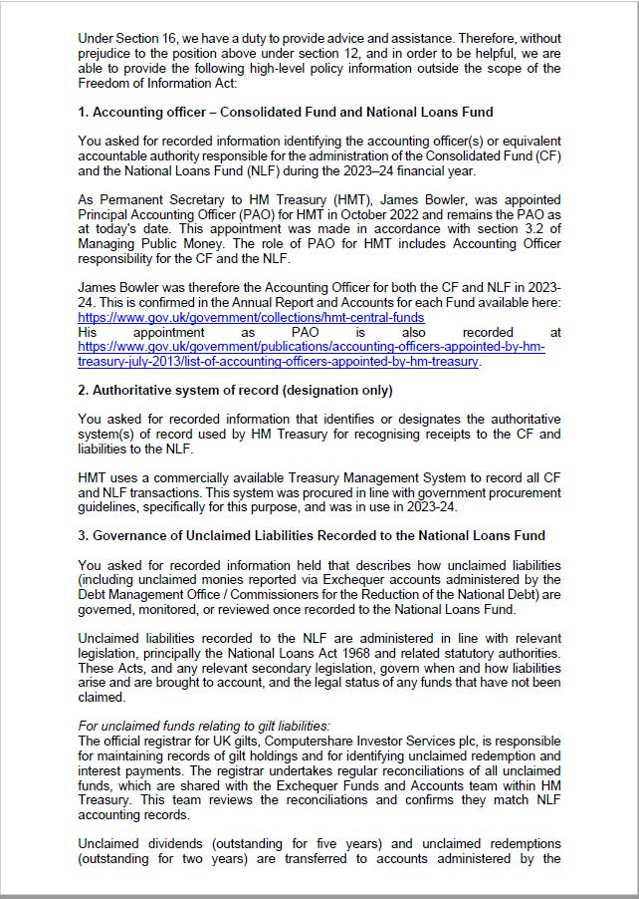

Once one moves from HMRC to the debt machinery, the one-pot story falls apart completely.
The most revealing exhibit in the stack is the Debt Management Office material showing what it calls the Exchequer Pyramid. This diagram is worth more than a dozen slogans. It sets out a hierarchy of accounts held at the Bank of England, including the Debt Management Account, the National Loans Fund, and other accounts including the Consolidated Fund. The accompanying text states that gilts are issued from the National Loans Fund and remain a liability of the NLF until maturity, while Treasury bills are issued from the Debt Management Account and remain a liability of the DMA until maturity.
That is not trivia. It means the state’s own internal financial map is not a single receiving account but a structured hierarchy. Different instruments sit in different channels. Borrowing is not simply folded into ordinary revenue. Treasury bills are not the same as gilts. The National Loans Fund is not the same thing as the Debt Management Account. And the Consolidated Fund sits within a wider system rather than exhausting it.
This is precisely the sort of thing that disappears from public debate because it is harder to narrate than “the government needs money.” But the machinery is the reality.

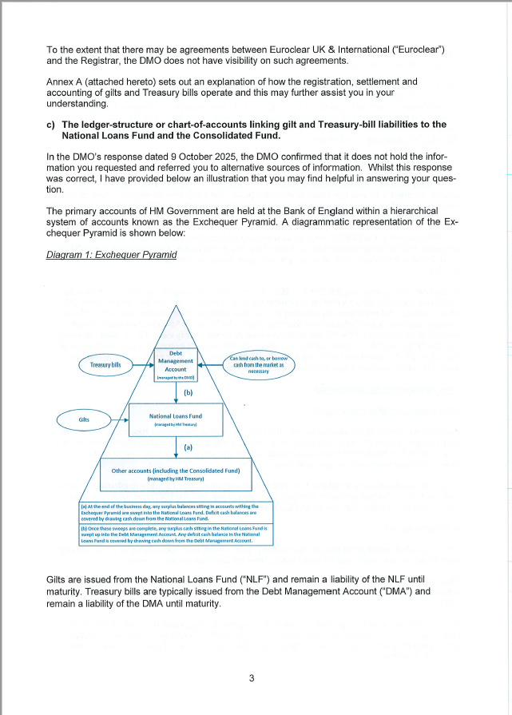

The picture becomes sharper still when one follows the treatment of unclaimed money.
The DMO states, in terms, that unclaimed payments relating to gilts are transferred to the unclaimed redemption account after two years and to the unclaimed dividend account after five years, that these accounts are administered by the Commissioners for the Reduction of the National Debt, and that the monies remain as a liability on the National Loans Fund until claimed.
That sentence deserves to be read slowly.
Unclaimed sums do not simply disappear into some general pool. They are transferred into named accounts. They are administered by a specific body. And they continue to exist as liabilities of a specific fund until claimed. This is not the language of a vague political abstraction called “government money”. It is the language of continuing formal obligations inside a layered accounting structure.
That matters for two reasons. First, it shows that liabilities persist in recognisable form long after the original payment event. Second, it shows that the official architecture is built to separate and classify these obligations rather than blur them into a single narrative of public finance.

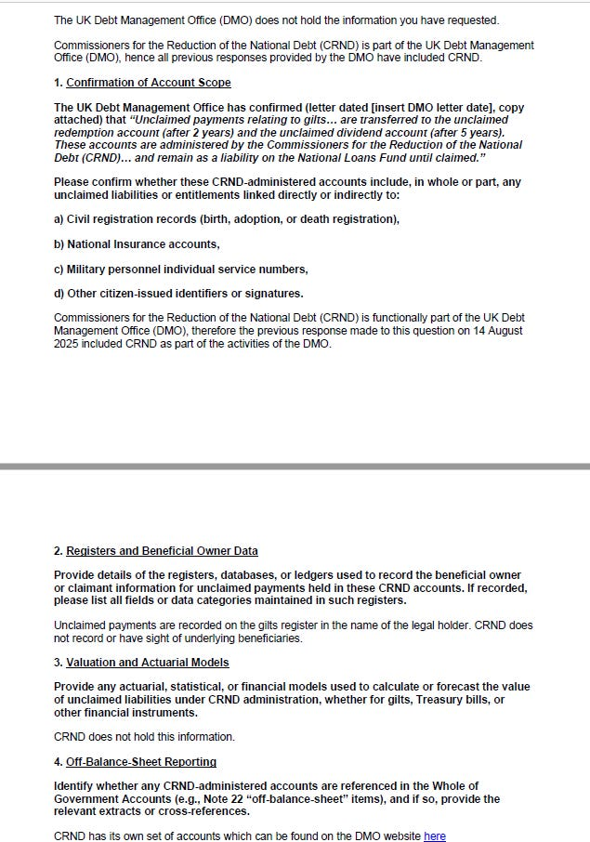

The next distinction is just as important, and in some ways even more revealing. The system records legal holders, not necessarily every underlying beneficial reality.
The DMO says that unclaimed payments are recorded on the gilt register in the name of the legal holder, and that CRND does not record or have sight of underlying beneficiaries. It also says that it has no record of beneficial entitlement to or indirect ownership of gilts and Treasury bills.
This is a crucial limit. It does not prove anything exotic by itself, nor should it be made to carry more weight than it can bear. But it does establish a structural fact. The public register view is a legal-holder view. The administration of certain liabilities proceeds on that basis. The state’s own machinery does not present itself as a universal window into all underlying beneficial interests. It records what it records, and it defines its own line of sight narrowly.
That is exactly why the language of simplicity is so misleading. Once one looks closely, the architecture is full of distinctions between legal holder and underlying interest, between collector and principal, between fund and account, between revenue and debt instrument, between departmental operation and Treasury administration. The public version compresses these into one story because the real one is harder to explain and less convenient to defend.
None of this requires speculative overreach. The point is serious enough without it.
HMRC says tax liabilities are statutory personal obligations, not securitised instruments and not trust claims. The DMO shows that public finance operates through a hierarchy of accounts and funds rather than a single receiving pot. The same DMO material shows that unclaimed gilt payments are not lost in a blur, but transferred into CRND-administered accounts and retained as liabilities on the National Loans Fund until claimed. And the registry view itself is confined to legal holders, with no visibility into underlying beneficiaries beyond that formal line.
Taken together, these are not random technicalities. They describe the state’s own plumbing.
That plumbing is layered, classified and mediated. It does not support the childish public picture of taxes flowing directly into one neat government pot and then out again in simple moral sequence. It supports something more administrative and more exact: a state that collects under statute, receives into historic funds, separates borrowing from ordinary revenue, records some relationships but not all, and continues to manage liabilities long after the public imagination has stopped paying attention.
This is why the language of contribution and spending so often conceals more than it reveals. It is not that the language is wholly false. It is that it leaves out the architecture in which those acts are actually processed. And once that architecture comes into view, the next question becomes unavoidable: if this is how the machinery really works, why is it so difficult to obtain a joined-up public account of it?
That is the question for the next piece in Part 6.
Because once the plumbing is visible, the real puzzle is no longer the machine itself.
It is why every institution seems determined to describe only one pipe at a time.

Subscribe to Dan's Substack
By moneyweasel · Launched 2 months ago
My personal Substack
Top of Form

Subscribe
Bottom of Form
By subscribing, you agree Substack's Terms of Use, and acknowledge its Information Collection Notice and Privacy Policy.

Discussion about this post
Top of Form

Bottom of Form
Part 4: Held Somewhere, Disclosable Nowhere
The latest FOIA replies do not show that government records do not exist. They show something more revealing: how records are fragmented, withheld…
Mar 17 • moneyweasel
2
1
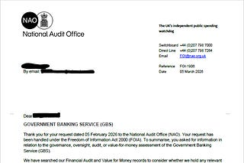
Part 6: Held Somewhere, Routed Elsewhere
Where does authority terminate?
Apr 13 • moneyweasel
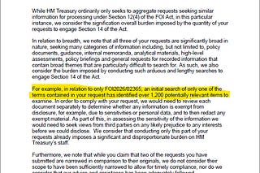
Part 2: The Machine Behind the Interest Rate
Last week I described what looked like a simple event: an interest rate doubling overnight on a consumer credit card.
Feb 25 • moneyweasel


Ready for more?
Top of Form

Subscribe
Bottom of Form
'Living Stones' is an unincorporated non-profit private ecclesiastical guild and trust.
Membership, annually or for life, is at a nominal charge upon proof of IS/EA-entity
plus your CV to confirm your skillset(s). All enquiries to the address below:
'Living Stones', Suite 303, 88 Queen Street, Sheffield, Yorkshire, England [S1 2FW]
- With apologies to Doctor Luke - 24.5 – why seek ye the DEAD among the living?!

